**Tableau Parts 5 and 6: Exercises with answers**

Exercise 5

1. Import the ‘employee.csv’, ‘department.csv’ and ‘project.csv’ files into Tableau. Combine all the 3 tables using Relationships by dragging the tables into the canvas.

Answer:

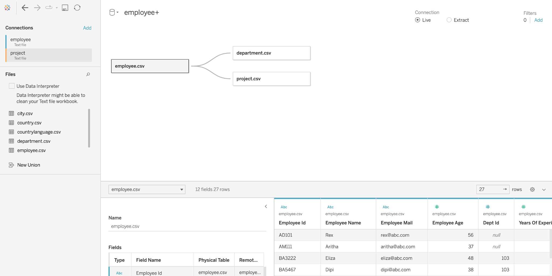

1. Draw a bar chart of total_hours_of_work on the x-axis versus both dept_id and project_id on the y-axis.

Answer: On a new sheet, drag the total_hours_of_work to the columns. Drag the dept_id and project_id to the Rows in the worksheet.

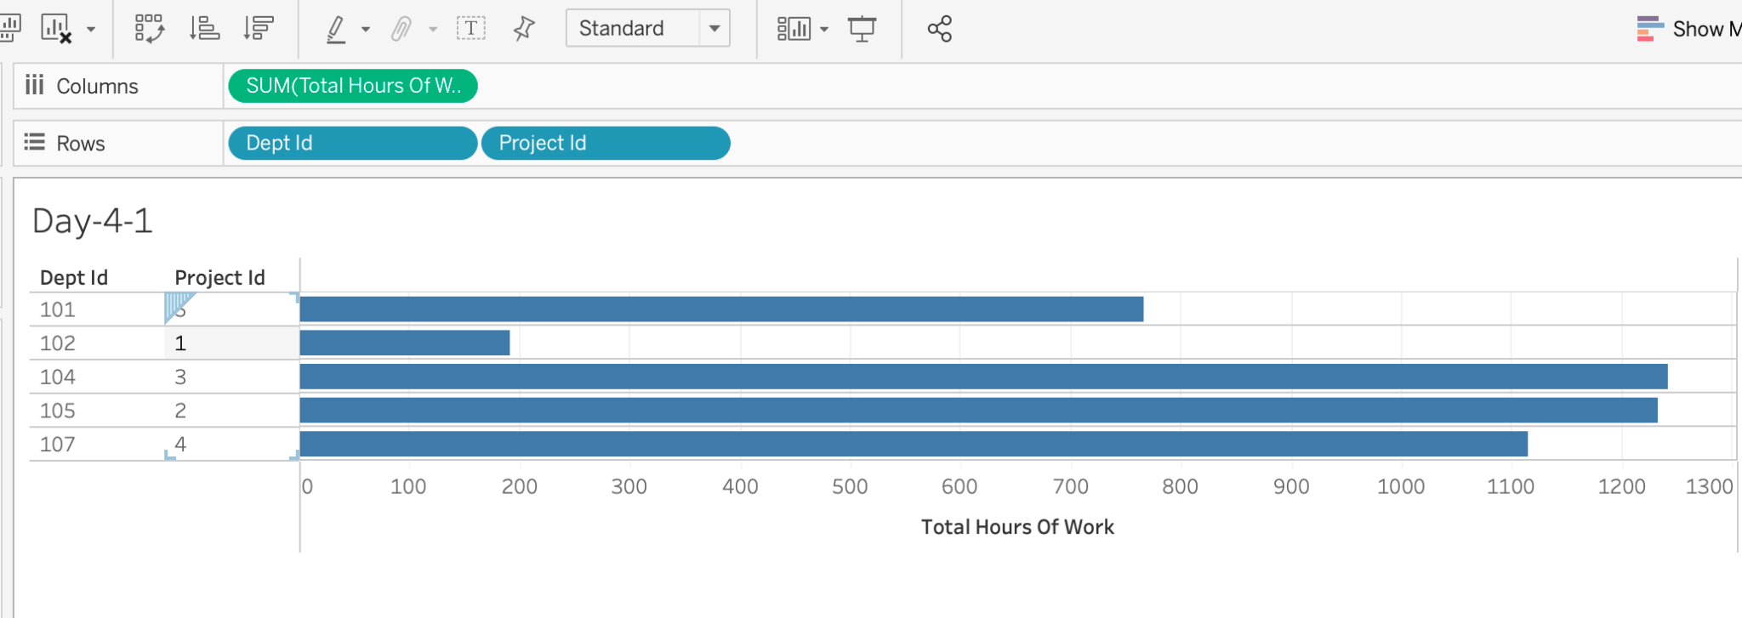

1. Add marks to this chart in any Green shade using the ‘Label’ button in the ‘Marks’ pane.

Answer: This can be done by clicking on the ‘Label’ button and checking the ‘Show marks labels.’

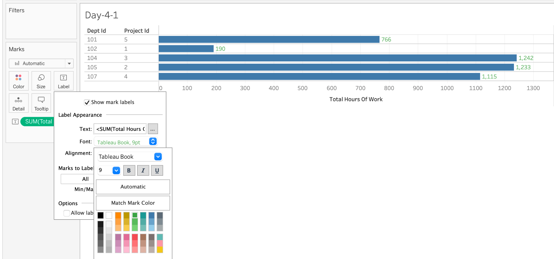

1. Annotate the department and project with the highest hours of work.

Answer: Right click in the area where the total_hours_of_work is maximum. Then click on Annotate -> Point. By default, total_hours_of_work: <SUM(total_hours_of_work)> must be generated. Upon clicking OK, the annotated box is visible.

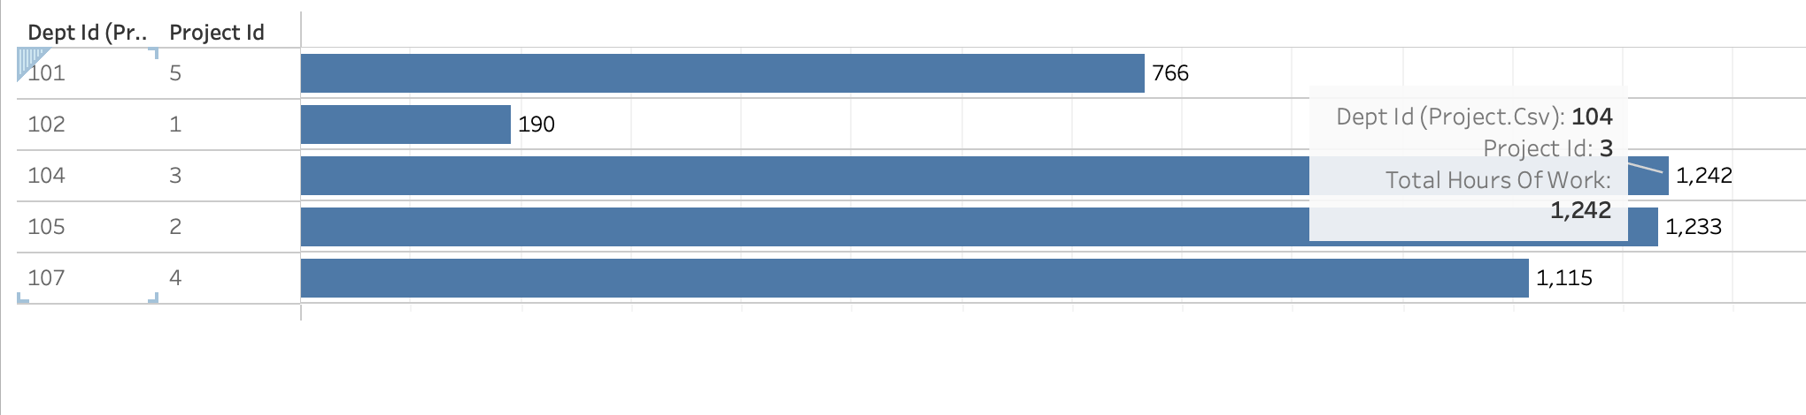

# Exercise 6

1. Use the employee table and plot a bar chart of dept_id in Columns and AVG(years_of_experience) in the Rows. Now create a function to calculate the median of years_of_experience. Add the function to Rows.

Answer:

